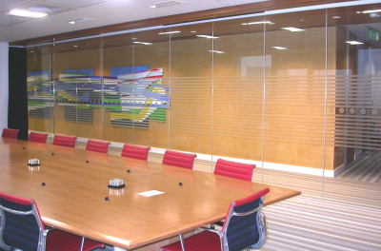

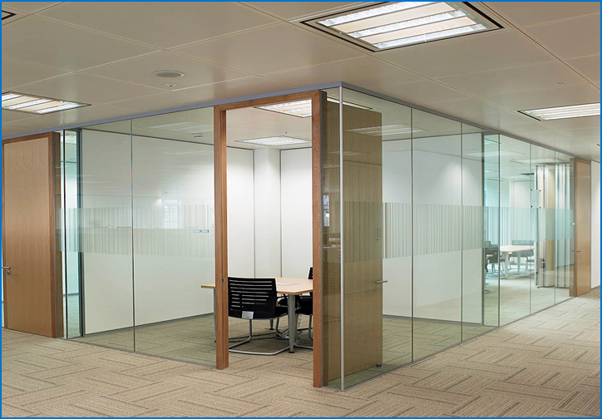

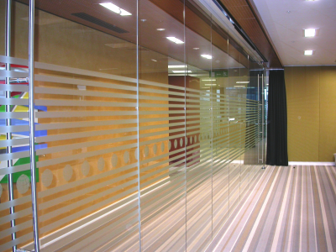

**Specification Clauses for**

**Optima 117 plus**

K30: Panel Partitions

1 November 2016

**Specifications**



**K30 – Panel Partitions (Single Glazed)**

**Optima 117 Plus**

**130 RELOCATABLE PARTITION SYSTEM**

(Insert description or location / usage)

* **Manufacturer:**
* Optima Products Ltd, Mill Road, Radstock, Nr. Bath BA3 5TX
* Optima Contracting Limited, Courtyard House, West End Road, High Wycombe HP11 2QB

(Insert Sales Contact Details)

OSCA Reference: (insert number)

* **Product Reference:**
* Optima 117 PLUS Single Glazed Partition System
* **Strength Grade:**
* Duty Rating to BS5234-2 not applicable to Frameless Glazed Partitioning

System designed for category of use: (Insert from following options)

* Uncongested Office Space – 0.36kN/m line load
* Congested Office Space – 0.74kN/m line load
* Public Access Space – 0.74kN/m line load
* Public Access Space – 1.50kN/m line load

- Maximum allowable deflection under the line load: (Insert from following options)

L/120 or 25mm (whichever is least)

L/65 or 50mm (whichever is least)

* **Fire Resistance of complete system to BS476 – 22:**
* Not applicable
* **Fire Rating for Panels:**
* Not applicable
* **Sound Insulation to BS EN ISO 10140 - 2 and ISO 717-1:** (Insert from following options)
* 32dB (Rw) - 10mm toughened glass - Estimated
* 33dB (Rw) - 12mm toughened glass - Lab Tested – see Performance Certificate 117133
* 35dB (Rw) - 10.8mm laminate glass - Lab Tested – see Performance Certificate 117134
* 36dB (Rw) - 12.8mm laminate glass - Estimated
* 37dB (Rw) - 10.8mm acoustic laminate glass - Lab Tested – see Performance Certificate 117135
* 38dB (Rw) - 12.8mm acoustic laminate glass - Lab Tested – see Performance Certificate 117136
* Aggregate screen value (partition plus door set): [Insert Value dB(Rw)]
* **Partition Height:**
* (Insert floor to ceiling height. NOTE: Maximum standard height 3000mm)
* **Partition Abutments:**
* Head detail (Deflection allowance): (Insert from following options)

117104-01 - 50mm deep x 25mm wide (no deflection)

117104-02 - 25mm deep x 25mm wide (no deflection)

117104-03 - Door head

117105-01 - 50mm deep x 36mm wide (no deflection)

117105-02 - 25mm deep x 36mm wide (no deflection)

117105-03 - Door head

117102-03 - 94mm deep (±25mm deflection – external)

117102-04 - Door head

117102-01 - 90mm deep (±25mm deflection – internal)

117102-02 - Door head

117103-03 - 140mm deep (±40mm deflection – external)

117103-04 - Door head

117103-01 - 135mm deep (±40mm deflection – internal)

117103-02 - Door head

* Floor detail: (Insert from following options)

117106-01 - 50mm deep x 25mm wide with clip-on bead

117106-02 - 25mm deep x 25mm wide with clip-on bead

117106-03 - 12mm deep back-to-back angles with silicone seal

117107-01 - 50mm deep x 36mm wide with clip-on bead

117107-02 - 25mm deep x 36mm wide with clip-on bead

* Wall detail: (Insert from following options)

117108-01 - 50mm deep x 25mm wide

117108-02 - 25mm deep x 25mm wide

117109-01 - 50mm deep x 25mm wide with clip-on bead

117109-02 - 25mm deep x 25mm wide with clip-on bead

117110-01 - 50mm deep x 36mm wide

117110-02 - 25mm deep x 36mm wide

117110-03 - ±25mm horizontal deflection

117111-01 - 50mm deep x 36mm wide with clip-on bead

117111-02 - 25mm deep x 36mm wide with clip-on bead

117112-01 - Door Frame Spacer for D350 Frame

117112-02 - Door Frame Spacer for D250 Frame

117117-01 - Tapeable glazing bar to 100mm generic drywall

117117-02 - Tapeable glazing bar to 122mm generic drywall

* **Framing:**
* Aluminium extruded track sections.
* **Glazing Junctions/Corners:**
* Glass-to-glass joints: (Insert from following options)

117119-01 - Nebula dry butt-joint

117119-02 - SA Aluminium dry butt-joint

117119-03 - Ghost dry butt-joint

117119-04 - Taped dry butt-joint

117119-05 - 90° mitred taped dry corner joint

117119-06 - SA Aluminium dry corner joint

117119-07 - Ghost dry corner joint

117119-08 - 90° taped dry corner joint

117120-01 - Taped 3-way to plain glass

117120-01 -02 - Taped 3-way to Nebula joint

117120-01 -03 - Taped 3-way to SA Aluminium joint

117120-01 -04 - SA Aluminium 3-way joint

117120-01 -05 - Ghost 3-way joint

* **Skirtings/Sills:**
* Not applicable: Refer framing clause and floor abutment clause
* **Trims:**
* Not applicable: Refer framing clause and head / floor / wall abutment clause
* **Solid Panels:**
* Not applicable: Refer Glazed Panels clauses
* **Glazing:**
* Full height, dry jointed and dry glazed with: (Insert from following options)

10mm toughened glass

12mm toughened glass

10.8mm laminate glass

12.8mm laminate glass

10.8mm acoustic laminate glass

12.8mm acoustic laminate glass

* **Manifestation:**
* To architects choice and in accordance with the requirements of Approved Document K: (Insert description)
* **Blinds:**
* Not applicable
* **Door sets:**
* Integral Microflush D350 aluminium door frame with 50mm face and leaf set: (Insert from following options)

*AXILE Clarity* frameless single glazed leaf on offset Quad pivots - Lab Tested to 32dB (Rw) with suitable threshold seal - See Performance Certificate 900185

*AXILE Clarity* frameless single glazed leaf on lift-off hinges - Lab Tested to 32dB (Rw) with drop seal – See Performance Certificate 900253

*AXILE Flush-Bond* frameless double glazed leaf on offset pivots - Lab Tested to 33dB (Rw) with suitable threshold seal – See Performance Certificate 900186

*EDGE Symmetry* single glazed leaf on offset pivots/hinges - Lab Tested to 35dB (Rw) – See Performance Certificate 900254

*EDGE Symmetry* double glazed leaf on offset pivots/hinges - Lab Tested to 41dB (Rw) – See Performance Certificate 900256

*EDGE Affinity* single glazed leaf on offset pivots/hinges - Lab Tested to 39dB (Rw) – See Performance Certificate 900257

*EDGE Affinity* double glazed leaf on offset pivots/hinges - Lab Tested to 42dB (Rw) – See Performance Certificate 900258

Timber 44mm leaf on offset pivots/hinges - Lab Tested up to 31dB (Rw) – See performance Certificate 900187

Timber 54mm rebated leaf on offset pivots/hinges - Lab Tested up to 33dB (Rw) – See Performance Certificates 900188 & 900195

* Integral Microflush D250 aluminium door frame with 50mm face and leaf set: (Insert from following options)

*AXILE Clarity* frameless single glazed leaf on offset Quad pivots - Lab Tested to 32dB (Rw) with suitable threshold seal - See Performance Certificate 900185

*AXILE Clarity* frameless single glazed leaf on lift-off hinges - Lab Tested to 32dB (Rw) with drop seal – See Performance Certificate 900253

*AXILE Flush-Bond* frameless double glazed leaf on offset pivots - Lab Tested to 33dB (Rw) with suitable threshold seal – See Performance Certificate 900186

*EDGE Symmetry* single glazed leaf on offset pivots/hinges - Lab Tested to 35dB (Rw) – See Performance Certificate 900254

*EDGE Symmetry* double glazed leaf on offset pivots/hinges - Lab Tested to 41dB (Rw) – See Performance Certificate 900256

*EDGE Affinity* single glazed leaf on offset pivots/hinges - Lab Tested to 39dB (Rw) – See Performance Certificate 900257

*EDGE Affinity* double glazed leaf on offset pivots/hinges - Lab Tested to 42dB (Rw) – See Performance Certificate 900258

Timber 44mm leaf on offset pivots/hinges - Lab Tested up to 31dB (Rw) – See performance Certificate 900187

Timber 54mm rebated leaf on offset pivots/hinges - Lab Tested up to 33dB (Rw) – See Performance Certificates 900188 & 900195

* *AXILE Pulse* frameless door on in-line pivots - Lab tested to 14dB (Rw) – See Performance Certificate 900271
* **Vision Panels:**
* Not applicable
* **Ironmongery:**
* To architects choice, from Optima standard ironmongery suite: (Insert description)
* **Cable Management / Outlets:**
* Not applicable
* **Accessories:**
* (Insert special requirements) Refer to Optima for advice.
* **Other Requirements:**
* Sustainability – System to conform to the requirements of (Insert from following options)
* SKA – Compliant with Good Practice Measure M09 – Ref. Sustainability Statement 117300
* BREEAM – Satisfies a rating of A+ against Green Guide Ratings 2008 – Ref. Sustainability Statement 117301
* BIM – System to come complete with Revit models to LOD 500
* (Insert special requirements) Refer to Optima for advice
* **Finish / Colour:**
* To architects choice from Optima standard range: (Insert from following options)

Powder coat RAL 9010 White (nom. 50 microns, 30% gloss)

Powder coat RAL 9006 Silver (nom. 50 microns, 30% gloss)

Powder coat non - standard colour (Refer to Optima for advice)

Anodised 25 microns thickness (Refer to Optima for advice)

Grained, Brightened and Protective Anodised (Refer to Optima for advice)

Polished, Brightened and Protective Anodised (Refer to Optima for advice)

**Appendix A Amendment Record**

|  |  |  |  |
| --- | --- | --- | --- |
| **Amendment Date** | **Details** | **How Communicated** | **Authorized by** |
| 18 March 2013 | First issue | E-mail to Optima Sales & Estimating Departments | P. Long |
| 23 March 2014 | Layout compacted | E-mail to Optima Sales & Estimating Departments | P. Long |
| 24 April 2015 | Door set options updated | E-mail to Optima Sales & Estimating Departments | P. Long |
| 1 Nov 2016 | Re-Format | E-mail to Optima Sales & Estimating Departments | P. Long |