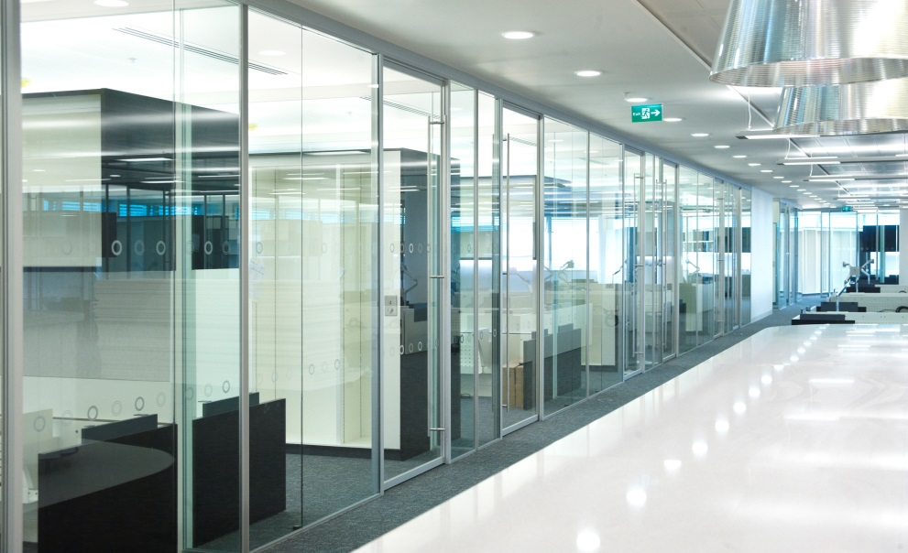

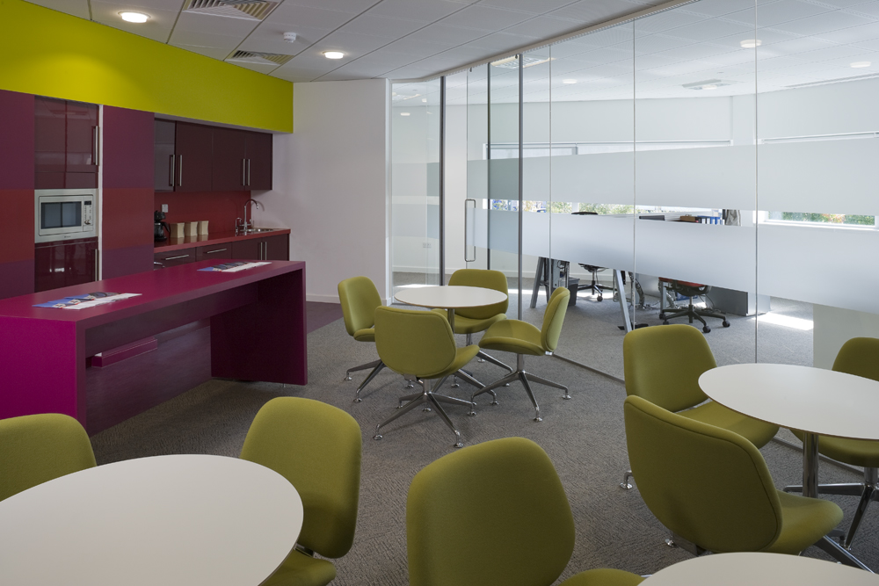

**Specification Clauses for**

**Kinetic Sliding Door System**

K30: Panel Partitions

L20: Doors

1 November 2016

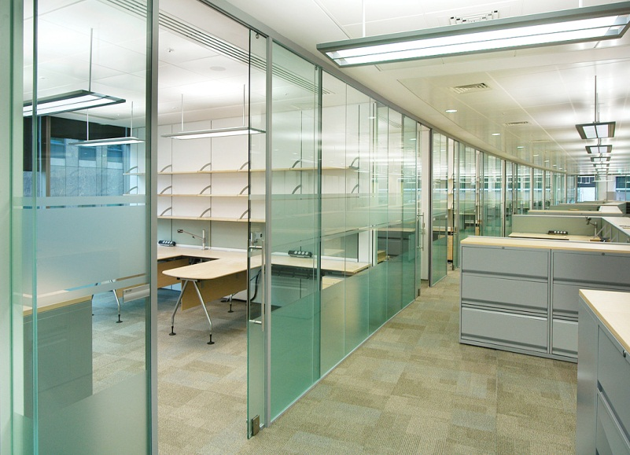

**Specifications**



**K30 – Panel Partitions (Single Glazed)**

**Kinetic Sliding Door System**

**130 RELOCATABLE PARTITION SYSTEM**

(Insert description or location / usage)

* **Manufacturer:**
* Optima Products Ltd, Mill Road, Radstock, Nr. Bath BA3 5TX
* Optima Contracting Limited, Courtyard House, West End Road, High Wycombe HP11 2QB

(Insert Sales Contact Details)

OSCA Reference: (insert number)

* **Product Reference:**
* Optima Kinetic Sliding Door System
* **Strength Grade:** (applicable to fixed glazing only)
* Duty Rating to BS5234-2 not applicable to Frameless Glazed Partitioning

System designed for category of use: (Insert from following options)

* Uncongested Office Space – 0.36kN/m line load
* Congested Office Space – 0.74kN/m line load

- Maximum allowable deflection under the line load: (Insert from following options)

L/120 or 25mm (whichever is least)

L/65 or 50mm (whichever is least)

* **Fire Resistance of complete system to BS476 – 22:**
* Not applicable
* **Fire Rating for Panels:**
* Not applicable
* **Sound Insulation to BS EN ISO 10140 - 2 and ISO 717-1:** (Insert from following options)
* 32dB (Rw) - 10mm toughened glass - Estimated
* 33dB (Rw) - 12mm toughened glass - Lab Tested (ref Optima 117 plus)
* 35dB (Rw) - 10.8mm laminate glass - Lab Tested (ref Optima 117 plus)
* 36dB (Rw) - 12.8mm laminate glass - Estimated
* 37dB (Rw) - 10.8mm acoustic laminate glass - Lab Tested (ref Optima 117 plus)
* 39dB (Rw) - 12.8mm acoustic laminate glass - Lab Tested – see Performance Certificate 300034
* 24dB (Rw) - Aggregate for 10mm SEAL door in 12.8mm acoustic laminate glass screen - Calculated from lab test data – see Performance Certificate 300046
* 33dB (Rw) - Aggregate for 10mm AERO door in 12.8mm acoustic laminate glass screen - Calculated from lab test data – see Performance Certificate 300041
* 36dB (Rw) - Aggregate for 12mm ALIGN door in 12.8mm acoustic laminate glass screen - Calculated from lab test data – see Performance Certificate 300044
* **Partition Height:**
* (Insert floor to ceiling height. NOTE: Maximum standard height 3000mm)
* **Partition Abutments:**
* Head detail (Deflection allowance): (Insert from following options)

50mm deep

94mm deep (±25mm deflection – external)

* Floor Detail:

25mm deep x 25mm wide with clip-on bead

* Wall Detail: (Insert from following options)

117108-02 - 25mm deep x 25mm wide (ref Optima 117 plus)

117109-02 - 25mm deep x 25mm wide with clip-on bead (ref Optima 117 plus)

117117-01 - Tapeable glazing bar to 100mm generic drywall (ref Optima 117 plus)

117117-02 - Tapeable glazing bar to 122mm generic drywall (ref Optima 117 plus)

* Door set-up: (Insert from following options)

LITE frameless door with deflection head to details:

300002-01 (horizontal section); 300002-02 (elevation); 300003-01 & 02 (vertical sections)

LITE frameless door with conventional head to details:

300004-01 (horizontal section); 300004-02 (elevation); 300005-01 & 02 (vertical sections)

SEAL frameless door with deflection head to details:

300006-01 (horizontal section); 300006-02 (elevation); 300007-01 & 02 (vertical sections)

SEAL frameless door with conventional head to details:

300008-01 (horizontal section); 300008-02 (elevation); 300009-01 & 02 (vertical sections)

AERO framed door with deflection head to details:

300010-01 (horizontal section); 300010-02 (elevation); 300011-01 & 02 (vertical sections)

AERO framed door with conventional head to details:

300012-01 (horizontal section); 300012-02 (elevation); 300013-01 & 02 (vertical sections)

ALIGN framed door with deflection head to details:

300014-01 (horizontal section); 300014-02 (elevation); 300015-01 & 02 (vertical sections)

ALIGN framed door with conventional head to details:

300016-01 (horizontal section); 300016-02 (elevation); 300017-01 & 02 (vertical sections)

* **Framing:**
* Aluminium extruded track sections
* **Glazing Junctions / Corners:**
* Glass-to-glass joints: (Insert from following options)

300019-01 - Nebula dry butt-joint

300019-02 - SA Aluminium dry butt-joint

300019-03 - Ghost dry butt-joint

300019-04 - Taped dry butt-joint

300019-05 - 90° mitred taped dry corner joint

300019-06 - SA Aluminium dry corner joint

300019-07 - Ghost dry corner joint

300019-08 - 90° taped dry corner joint

300020-01 - Taped 3-way to plain glass

300020-02 - Taped 3-way to Nebula joint

300020-03 - Taped 3-way to SA Aluminium joint

300020-04 - SA Aluminium 3-way joint

300020-05 - Ghost 3-way joint

* **Skirtings/Sills:**
* Not applicable: Refer framing clause and floor abutment clause
* **Trims:**
* Not applicable: Refer framing clause and head / floor / wall abutment clauses
* **Solid Panels:**
* Not applicable: Refer Glazed Panels clauses
* **Glazing:**
* Full height, dry jointed and dry glazed with: (Insert from following options)

10mm toughened glass

12mm toughened glass

10.8mm laminate glass

12.8mm laminate glass

10.8mm acoustic laminate glass

12.8mm acoustic laminate glass

* **Manifestation:**
* To architects choice and in accordance with the requirements of Approved Document K: (Insert description)
* **Blinds:**
* Not applicable
* **Door Sets:**
* Integral Sliding Door: (Select from following)

LITE door - Frameless with no acoustic seals

SEAL door - Frameless with slam post and acoustic seals to top and vertical edges

AERO door - Fully framed door with slam post and acoustic seals to all edges

ALIGN door - Fully framed door with overlapped closure and acoustic seals to all edges

* **Ironmongery:**
* To architects choice, from Optima standard ironmongery suite: (Insert from following options)
* Locking: (select from)

Non-locking

Standard SEAL locking with patch hook bolt lock and Europrofile cylinder & turn

Standard AERO locking with mortised hook bolt lock and Europrofile cylinder & turn

Standard ALIGN locking with screen-mounted mortised hook bolt lock and Euro-profile cylinder & turn

* Handles: (select from)

Pull handles in SSS finish (insert diameter, length and style)

* Non-standard ironmongery suite: (Insert details)
* **Cable Management / Outlets:**
* Not applicable
* **Accessories:**
* (Insert special requirements) Refer to Optima for advice
* **Other Requirements:**
* Sustainability – System to conform to the requirements of (Insert from following options)
* SKA – Compliant with Good Practice Measure M09 – Ref. Sustainability Statement 300300
* BREEAM – Satisfies a rating of A+ against Green Guide Ratings 2008 – Ref. Sustainability Statement 300301
* BIM – System to come complete with Revit models to LOD 500
* (Insert special requirements) Refer to Optima for advice
* **Finish / Colour:**
* To architects choice from Optima standard range: (Insert from following options)

Powder coat RAL 9010 White (nom. 50 microns, 30% gloss)

Powder coat RAL 9006 Silver (nom. 50 microns, 30% gloss)

Powder coat non - standard colour (Refer to Optima for advice)

Anodised 25 microns thickness (Refer to Optima for advice)

Grained, Brightened and Protective Anodised (Refer to Optima for advice)

Polished, Brightened and Protective Anodised (Refer to Optima for advice)

**Appendix A Amendment Record**

|  |  |  |  |
| --- | --- | --- | --- |
| **Amendment Date** | **Details** | **How Communicated** | **Authorized by** |
| 18 March 2013 | First issue | E-mail to Optima Sales & Estimating Departments | P. Long |
| 24 March 2014 | Layout compacted | E-mail to Optima Sales & Estimating Departments | P. Long |
| 24 April 2015 | Minor text amendment | E-mail to Optima Sales & Estimating Departments | P. Long |
| 1 Nov 2016 | Re-Format | E-mail to Optima Sales & Estimating Departments | P. Long |
|  |  |  |  |
|  |  |  |  |